**3. What is the difference between collections and streams? Explain with an Example**

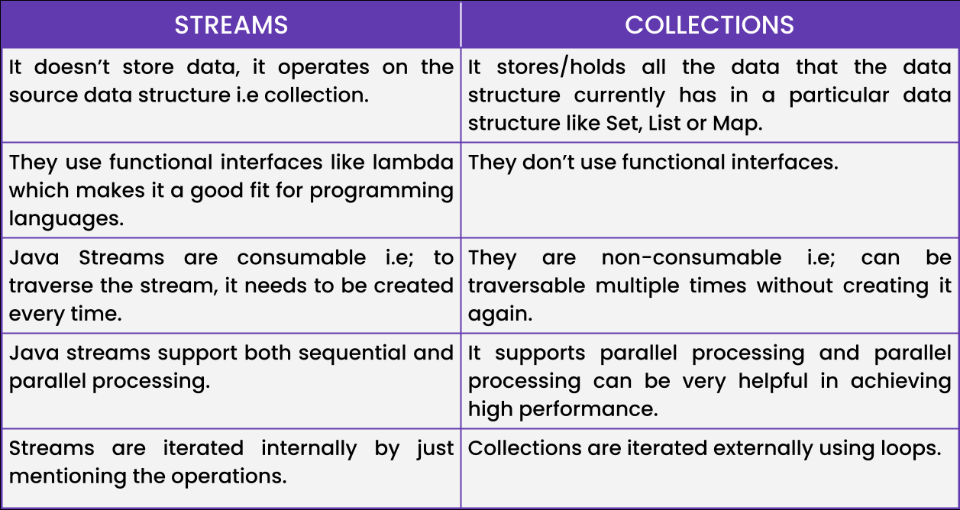

**4. What is enums in java? explain with an example**

**Ans:** We can use enum to define a group of named constants. Enums are used to represent a collection of related constants that have a common purpose. Each constant in an enum is an instance of the enum type, and they are typically defined as public static final fields.

Here's an example of how to define an enum in Java:

class EnumDemo{

public enum DayOfWeek {

MONDAY,

TUESDAY,

WEDNESDAY,

THURSDAY,

FRIDAY,

SATURDAY,

SUNDAY

}

public static void main(String args[]){

for(DayOfWeek d:DayOfWeek.values())

System.out.println(d);

}

}

Here we define an enum called "DayOfWeek" that represents the days of the week. The enum has seven

constants, each representing a day of the week. The constants are defined in all uppercase letters by convention.

**5. What are in built annotations in java?**

**Ans:** built-in annotations in Java:

@Override

@Deprecated

@SuppressWarnings

@FunctionalInterface

@Retention

@Target

@Documented

@Inherited

These built-in annotations in Java are used to provide additional information to the Java compiler and other tools. They help improve code readability, maintainability, and safety by enforcing specific rules and behaviours in Java code.